I
l> ,£ Buselli Plumbing Heating and Electric
'' Site Report

Report Name
Report Date Declination Location Lat/Long Weather Station Site Distance

Report Type

Array Type Tilt Angle
Ideal Tilt Angle Azimuth
Ideal Azimuth

Electric Cost

Panel Make Panel Model Panel Count
DC Rate (per panel) Total System Size
Inverter Make
Inverter Model Inverter Count
Derate Method Derate Factor
Xxxx xxxxxxxxx
1/16/2014 7:03:37 AM
-12d 46m
Callicoon, NY 12723
41.782 1-74.984
Binghamton-Edwin A Link Field, NY, Elevation: 1,601 Feet, (42.200/-75.983) 59 Miles

PV

Fixed Angle
30.00 deg 30.00 deg
180.00 deg
180.00 deg

0.1 ($/KWH)

Canadian Solar CS6P-250P
30
250.0 Watts
7,500.0 Watts Power-One
MICR0-0.25-1-0UTD-US-240 30
Using Components 0.803

Layout Configuration Single Picture Layout Point Count 1
Notes: address

Report generated by SolarPathfinder Assistant Version 4.1.44.0. http://www .solarpathfinder.com Page: 1/4

':\l)i,.f,,,,

Buselli Plumbing Heating and Electric Solar Site Analysis Report

Image File pathfinder.JPG

Solar Obstruction Data
Month Actual Shaded Actual Shaded Actual Unshaded Ideal Unshaded PV Solar PVWatts Unshaded Actual Site Ideal Site Solar Radiation AC Energy (KWH) AC Energy (KWH) AC Energy (KWH) Cost Savings % Actual Site Efficiency % Efficiency %
Azimuth=180.0 Azimuth=180 .00 Azimuth= 180.0 Azimuth=180 .0 0.1 ($/KWH) Azimuth=180.0 Azimuth=180.0 Azimuth=180 .0
Tilt=30.0 Tilt=30.00 Tilt=30.00 Tilt=30.00 Tilt=3o.oo Tilt=30.00 Tilt=30.00
2

KWH/m
/day

January | 2.39 | 476.80 | 507.00 | 507.00 | $47.68 | 91.44 % | 91.44 % | 91.44 %
February | 3.11 | 569.40 | 632.00 | 632.00 | $56.94 | 87.71 % | 87.71 % | 87.71 %
March | 3.55 | 669.87 | 744.00 | 744.00 | $66.99 | 88.19 % | 88.19 % | 88.19 %
April | 4.11 | 730.33 | 847.00 | 847.00 | $73.03 | 84.12 % | 84.12 % | 84.12 %
May | 4.60 | 823.00 | 960.00 | 960.00 | $82.30 | 84.00 % | 84.00 % | 84.00 %
June | 4.40 | 739.00 | 887.00 | 887.00 | $73.90 | 81.65 % | 81.65 % | 81.65 %
July | 4.60 | 797.00 | 950.00 | 950.00 | $79.70 | 82.29 % | 82.29 % | 82.29 %
August | 4.45 | 773.80 | 915.00 | 915.00 | $77.38 | 82.66 % | 82.66 % | 82.66 %
September | 4.05 | 708.38 | 786.00 | 786.00 | $70.84 | 87.84 % | 87.84 % | 87.84 %
October | 3.17 | 583.80 | 626.00 | 626.00 | $58.38 | 90.75 % | 90.75 % | 90.75 %
November | 2.29 | 422.92 | 447.00 | 447.00 | $42.29 | 91.30 % | 91.30 % | 91.30 %
December | 2.01 | 393.23 | 409.00 | 409.00 | $39.32 | 93.07 % | 93.07 % | 93.07 %
Totals | 42.70 | 7,687.54 | 8,710.00 | 8,710.00 | $768.75 | 87.09 % | 87.09 % | 87.09 %
 | Effect:86.02% |  |  |  |  | Unweighted | Unweighted | Unweighted
 | Sun Hrs: 3.56 |  |  |  |  | Yearly Avg | Yearly Avg | Yearly Avg
Notes: | [None]

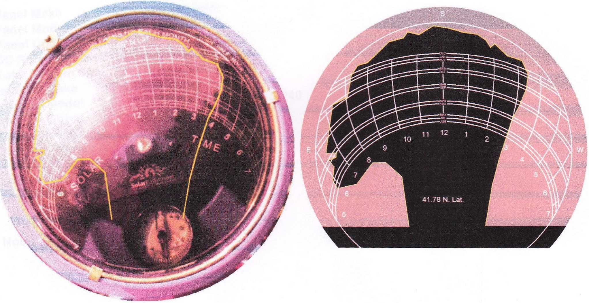

Report generated by SolarPalhfinder Assistant Version 4 .1.44.0. http://www.solarpathfinder.com Page: 4/4

I

