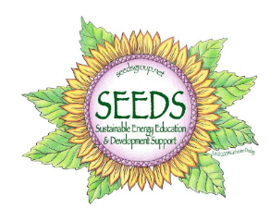
FREE Sustainable Energy Sessions
for Wayne Pike BIA

Please join us on the first Thursdays of Jan., Feb., and March for
FREE SEMINARS AND SUPPER!

Jan 7 – SOLAR – how it works and how much it costs, how to build for maximum solar potential and analyze an existing site to see if solar makes financial sense. Help clients with questions about whether solar works for them.
Feb 4- Designing & Buildings for Maximum Energy Efficiency - designing for maximum energy efficiency. Will include building tips to seal the building’s envelope and maximize the sun’s heat and light.
March 3 – Ground/Air Source Heat Pumps –efficiency advancements in mini split HVAC technology in just the last couple of years have changed everything, making them a great heating and cooling choice for many more buildings.
Presenters include Peter Vargo of Nu-Tech Energy Solutions, and 2 local solar installers: Gordon Smith of Renewable Energy Solutions and Blair Buselli of Buselli Solutions, both serve on SEEDS Advisory Committee.
Dinner served at 5:30; Presentation from 6 – 7 pm, Q&A to follow
At the Hawley Senior Community Center - 337 Park Place - corner of Bingham Park in Hawley
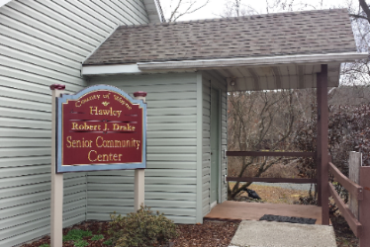
Registration is required since dinner is being provided.
Please email: jocelyn@seedsgroup.net or call (570) 245 – 1256. Come to one, come to all! Please let us know when you register.
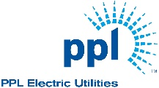PPL and SEEDS are sponsoring these sessions tailored for the building industry to better serve clients seeking energy efficient homes and/or solar installations, and to introduce SEEDS (Sustainable Energy Education and Development Support) as a resource and support system. SEEDS will keep Wayne Pike Building Industry Associate members abreast of all PPL rebates and incentives for energy efficiency and renewable energy installations.
SEEDS is a local non-profit organization promoting sustainable energy in our region.
www.seedsgroup.net. 1020 Main Street – 2nd Floor of The Cooperage; Honesdale, PA 18431
(570) 245 – 1256; jocelyn@seedsgroup.net

