SEEDS Home Energy Assessment Team Volunteer Application 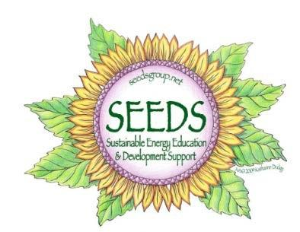

Applications due Wednesday, May 2, 2025

Submit applications to [kathy@seedsgroup.net](mailto:kathy@seedsgroup.net)

Full Name: ______________________________________________________________________________

Nickname: __________________________ Email: ______________________________________________ Address: _________________________________________________________________________________ Home Phone: _______________________________ Cell Phone: ___________________________________

1. Why are you interested in becoming an assessment volunteer?

1. What experience do you have with energy conservation, building science, construction, and/or waste reduction?

1. Please describe your experience and comfort with customer service/people skills.

1. Training will start with a reading assignment sent on May 20. Two hour evening zooms on May 28, 30, and June 3, 2025. Hands-on training all day on either June 6 or 7. Can you attend these training dates?
2. Are you available to participate for approximately 3 to 4 hours one or two days a week from June through mid-August? Try to be specific about the best times and days you might be available.

1. Do you have access to a computer and phone, so that you may be able to do some work from home?
2. Are you able to participate on weekends if need be?
3. Do you plan to be on vacation during the summer? If so, when are you NOT available?
4. Do you have a car/Driver’s License?

1. We require all members of our assessment teams and assessment clients to be fully vaccinated for Covid and to wear masks (provided by SEEDS) while on assessments if conditions warrant. Please confirm your compliance with these regulations:

1. Do you have any allergies or medical conditions that we should know about to help keep you safe?

1. Anything else you would like to share?

Do you receive our free monthly e-newsletter about SEEDS events & programs, renewable energy topics and local sustainability initiatives? If not, do we have your permission to add your provided email to our list? Yes No

Please like us on Instagram, bluesky and Facebook! It helps us reach more members of our community and demonstrate how many people care about our mission!

Facebook: www.facebook.com/seedsofnepa / Instagram: @SEEDSofNEPA/BlueSky: seedsofnepa.bsky.social

Thank you for your interest in joining the SEEDS Energy Efficiency Assessment Team!